Press Release: Richard Bangs’ Adventures with Purpose
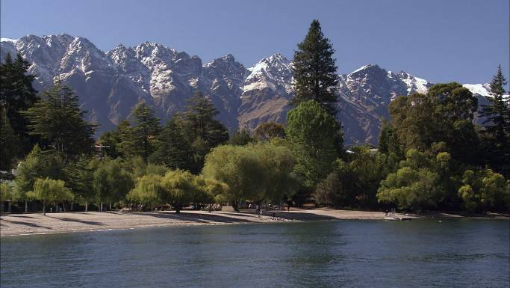
Richard Bangs’ Adventures with Purpose, a new, one-hour special from American Public Television, will air on _________ (station) _________________ at (time) _______, (day) __________ (date) _________. Hosted by Richard Bangs who is often called “the father of modern adventure travel,” Adventures with Purpose “New Zealand: Quest for Kaitiakitanga” is another pilot episode for a series of adventure travel, eco-conscience, historical documentaries. According to Bangs, “Adventures with Purpose not only quicken the pulse and fire the synapses, they are also journeys of enlightenment and discovery—odysseys that make a difference.”
Adventures with Purpose is produced by Small World Productions, the makers of Smart Travels—Europe and Pacific Rim with Rudy Maxa and Travels in Europe with Rick Steves. The special is co-produced by KCTS/Seattle, and Richard Bangs Productions of Marina del Rey, California.

This time Richard Bangs is near the southernmost reaches of civilization, in a down under world with an upright world-view—New Zealand. The massive lands of the Northern Hemisphere may tip the scales with their acreage, but today small New Zealand is proving to be more than good balance. It’s become a model for the world in its pursuit of a sustainable environment. Viewers join Richard as he traverses the most physically and climatically diverse landmass in Polynesia in search of an age-old Māori concept that might hold a key to our planet’s future survival.

According to Bangs, “There is something irresistible about New Zealand’s natural beauty, something ever-alluring about its deep culture; and something enigmatic about how it seems more pristine with each visit.”

New Zealand was the last major landmass settled by humans, by men and women in stout canoes who traveled thousands of miles across the Pacific. The descendents of those early Polynesian explorers, known as Māori, developed their own mythology and value system to help them survive in this mystifying new world. Now, Bangs is setting off to seek some modern answers rooted in indigenous wisdom, hoping to unearth the meaning and origins of something Māori call “Kaitiakitanga”. This complex cultural guideline evokes something like “caretaking” or “guardianship.” An important element of “Kaitiakitanga” is the responsibility human beings have to protect the physical world, including the land, seas and skies.

What’s old is new. Today’s Kiwis, people of both European and Māori descent, are promoting the idea that the knowledge of the ancients may be the secret to the preservation of our planet, for our children and our children’s children.

Bang discovers why today there’s an enthusiastic new wave of promoters of this age-old concept, and sees how its practice is playing out in modern New Zealand.
  Adventures with Purpose | Small World Productions  140 Lakeside, Suite 200, Seattle 98122  206.329.7167  info@travelsmallworld.com  www.AdventuresWithPurpose.TV

Richard Bangs’ Adventures with Purpose
Press Release, Page 2

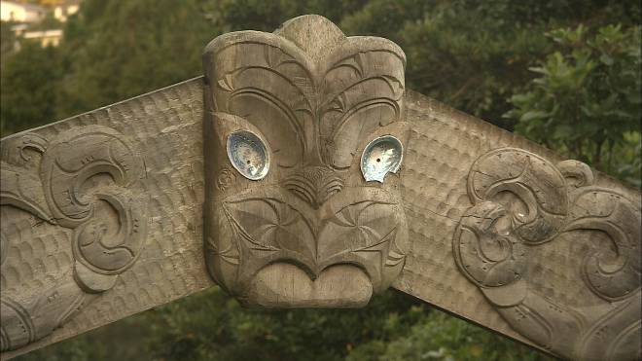
On this journey, Bangs begins in the south, in Mt. Aspiring National Park. Then he navigates north to the Franz Joseph Glacier and on to the town of Kaikoura. He’ll cross the Cook Strait to the North Island, stopping in Wellington, the Taupo region, and Hokianga Harbor. Finally, he arrives on the upper tip of New Zealand, where there is a great tangled tree of Māori legend.

Host and co-executive producer, Richard Bangs is a pioneer in travel that makes a difference, travel with a purpose. He has spent 30 years as an explorer and communicator, and along the way led first descents of 35 rivers around the globe, including the Yangtze in China and the Zambezi in Southern Africa. Richard has published more than 1000 magazine articles, 17 books, a score of documentaries and CD-ROMs; and has lectured at the Smithsonian, the National Geographic Society, the Explorers Club and many other notable venues. He writes a semi-regular feature for the NY Times. His latest book, Quest for Kaitiakitanga, will be published in February, 2008, by Menasha Ridge Press. It’s a companion to this television special.

DVDs and VHS home videos of Adventures with Purpose: Quest for Kaitiakitanga are available from Small World Productions. Each DVD contains the complete show and more than an hour of value added bonuses: Richard’s adventure travel tales, never-before-seen bonus footage, and behind the scenes glimpses. Richard’s Quest for Kaitiakitanga books, DVDs and videos are $24.95 each plus shipping. The book and DVD may be ordered together for $44.95 plus shipping. Viewers may order online at www.AdventuresWithPurpose.TV or call the order desk at 800.866.7425.

Small World Productions, Inc. of Seattle produces Richard Bangs’ Adventures with Purpose. KCTS/Seattle and Richard Bangs Productions are co-producers. KCTS is the presenting station. Exofficio Travel Apparel, Travel Link and Air New Zealand provided partial support for production and distribution of the series.

HDTV versions of Adventures with Purpose will be up-linked on the public television HD satellite transponder. And a NTSC, or standard definition, “letterboxed” version, will air on more that 250 public television stations as well. Digital audio is transmitted in stereo.

For 44 years, American Public Television (APT) has been a prime source of programming for the nation’s public television stations. APT distributes more than 10,000 hours of programming including JFK: Breaking the News, Simply Ming, Globe Trekker, Smart Travels—Pacific Rim, Julia and Jacques Cooking at Home, Battlefield Britain, Jungle, America’s Test Kitchen, Lidia’s Italian-American Kitchen and classic movies. APT is known for identifying innovative programs and developing creative distribution techniques for producers. In four decades, it has established a tradition of providing public television stations nationwide with program choices that enable them to strengthen and customize their schedules. The APT press contact is Dawn Anderson at 617-338-4455 ext-149 or via email: dawn_anderson@APTonline.org. For more information about APT’s programs and services visit APTonline.org.
Adventures with Purpose | Small World Productions  140 Lakeside, Suite 200, Seattle 98122  206.329.7167  info@travelsmallworld.com  www.AdventuresWithPurpose.TV
# # #

Contact: John Givens, Small World

